University of Applied Sciences in Tarnów

Department of Computer Science



Field of study: Computer science
Academic year: 2024/2025
Course: Knowledge and Business Process Engineering

Kierunek studiów: Informatyka
Rok akademicki: 2024/2025
Kurs: Inżynieria wiedzy i procesów biznesowych

System fitness do zakupu karnetów i zapisu na treningi personalne

Authors:
Kajetan Nowak
Wiktor Warmuz
Stanisław Mendel
Damian Ciura

Academic teacher:
mgr inż. Potempa Tomasz
Oświadczam, że niniejsza praca przejściowa:
1) jest mojego/naszego autorstwa i nie narusza praw autorskich w rozumieniu ustawy z dnia 4 lutego 1994 roku o prawie autorskim i prawach pokrewnych (tekst jednolity Dz. U. Nr 90 z 2006 r., poz. 631 z późn. zm.) oraz dóbr osobistych chronionych prawem cywilnym;
2) nie zawiera danych i informacji, które zostały uzyskane w sposób niedozwolony;
3) nie była w latach wcześniejszych podstawą zaliczenia niniejszego przedmiotu innej osobie.

Authors’ contributions:
Stage / Author | Kajetan Nowak | Wiktor Warmuz | Stanisław Mendel | Damian Ciura
Conceptual design  10 points | 25% | 25% | 25% | 25%
Business process models design  30 points | 25% | 25% | 25% | 25%
Business processes and rules implementation  50 points | 40% |  | 30% | 30%
Testing and optimization of business processes  10 points |  | 100%
Author’s participation  100 points | 10 pkt * 25%+  30 pkt * 25%+  50 pkt * 40%=  30 points | 10 pkt * 25%+  30 pkt * 25%+  10 pkt * 100%=  20 points | 10 pkt * 25%+  30 pkt * 25%+  50 pkt * 30%=  25 points | 10 pkt * 25%+  30 pkt * 25%+  50 pkt * 30%=  25 points
Table of contents:
1. Conceptual design. 4
1.1 Project description 4
1.2 List of processes. 4
1.3 Description of processes. 4
1.3.1 “Training Assign”. 4
1.3.2 “Register”. 4
1.3.3 “Login”. 4
1.3.4 “Gym Membership Payment”. 4
2. Business process models design. 5
3. Business processes and rules implementation. 7
4. Testing and optimization of business processes 7
4.1. “Training Assign”. 7
4.1.1. Visualization. 7
4.1.2. Conclusions. 7
Drawing index:
Drawing 1: Training Assign 5
Drawing 2: Register 5
Drawing 3: User Mail Verification 5
Drawing 4: Login 6
Drawing 5: Gym Membership Payment 6
Drawing 6: Membership Fee Payment Request 6

- Conceptual design.
  - Project description

The main objective of the project is to describe, design, and implement a gym membership management system. The system enables users to sign up for training sessions, pay for memberships, and provides functionalities such as logging in and registering in the system.

  - List of processes.
- “Training Assign”
- “Register”
- “Login”
- “Gym Membership Payment”

  - Description of processes.
    - “Training Assign”.
The "Training Assign" process allows the user to choose a convenient training session. The process begins with the system displaying the available training sessions. The user then selects the training session that suits them from the presented list. In case of an error, the system returns to the point where it shows the available training sessions.
    - “Register”.
The "Register" process involves the user's self-registration in the system. After entering and confirming the data in the appropriate form, the system verifies its correctness. Then, to verify the email address, a message with a verification code is sent to the address provided by the user. This process is time-limited. If all steps are completed correctly, the user is registered in the system.
    - “Login”.
The "Login" process involves the user's self-login into the system. After entering and confirming the data in the appropriate form, the system verifies its correctness. If all the data is entered correctly, the user is logged into the system and gains access to all functionalities that are not blocked by the system due to the role assigned to the user.
    - “Gym Membership Payment”.
The "Gym Membership Payment" process is initiated by the system, which calculates the payment amount and then starts the payment process. The first step in the payment process is securing the appropriate amount from the account. If the secured amount is sufficient, the payment is successfully completed. If there are insufficient funds in the account, the system requires the payer to change the payment card. Upon successful completion of this action, the system correctly finalizes the payment process. Otherwise, the system verifies the payment request up to 5 times, allowing the payer to select a new card.

- Business process models design.
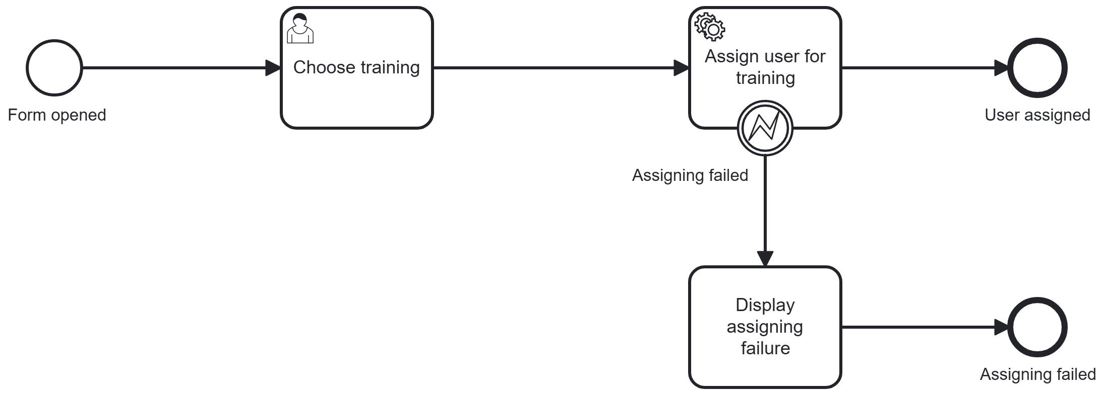
Drawing 1: Training Assign
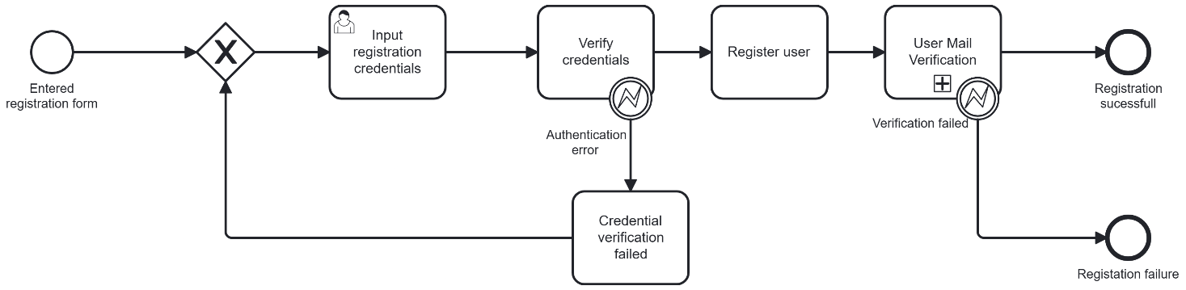
Drawing 2: Register
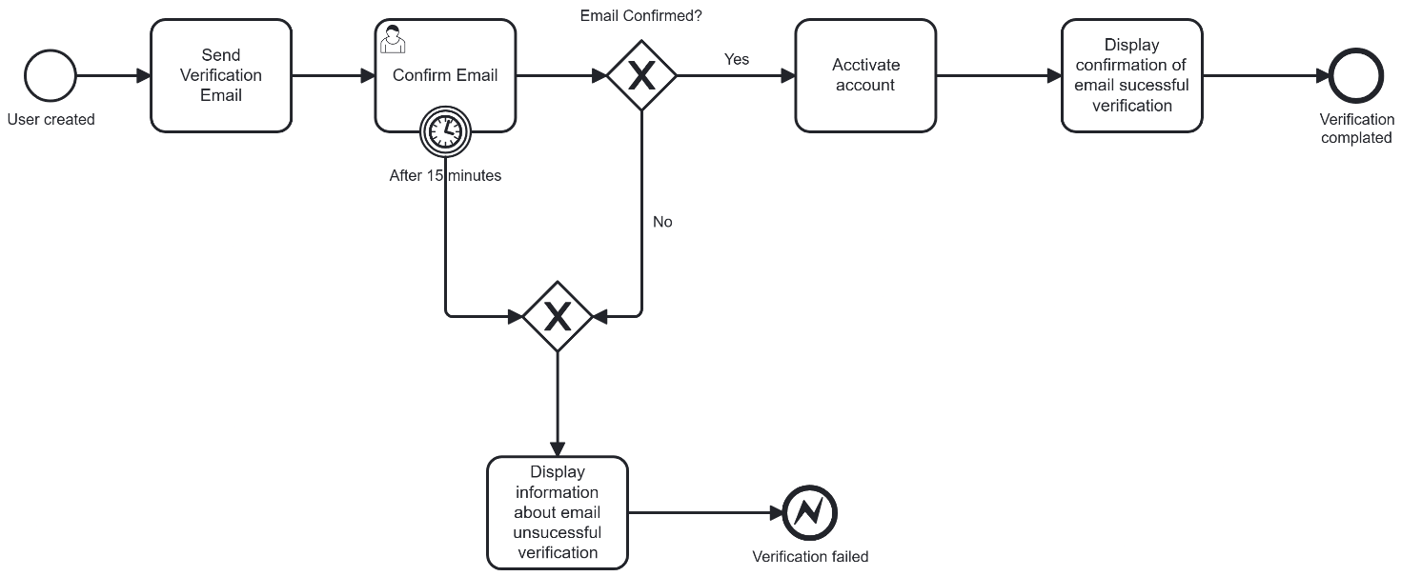
Drawing 3: User Mail Verification
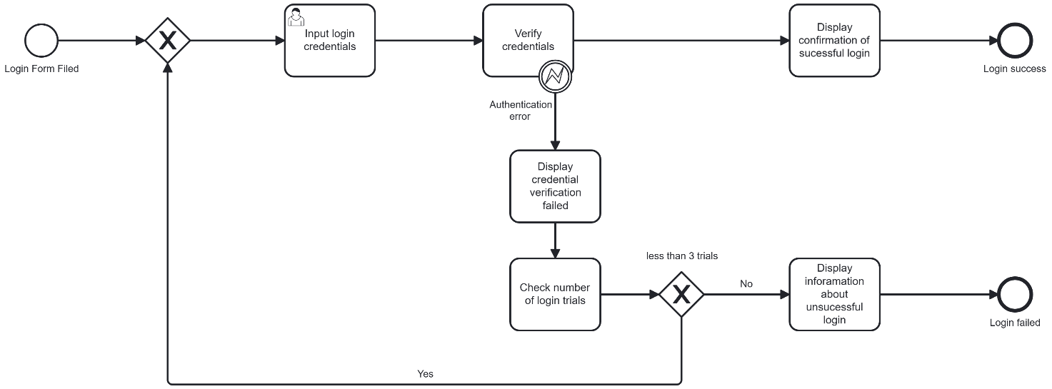
Drawing 4: Login
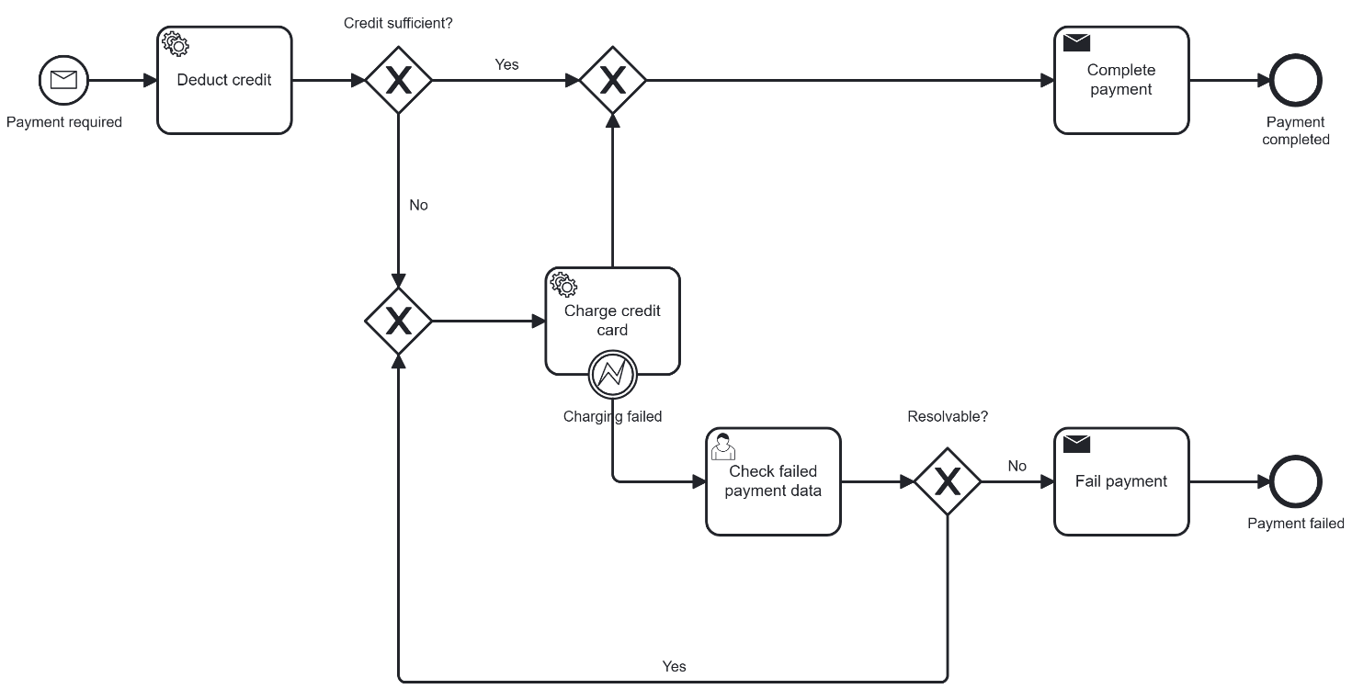
Drawing 5: Gym Membership Payment

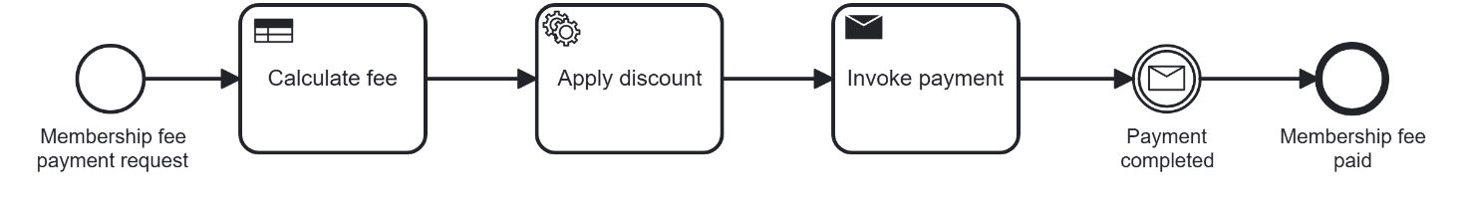
Drawing 6: Membership Fee Payment Request

- Business processes and rules implementation.

Reference to the project source repository: https://github.com/CiuraD/silownia

- Testing and optimization of business processes
  - “Training Assign”.

    - Visualization.
    - Conclusions.
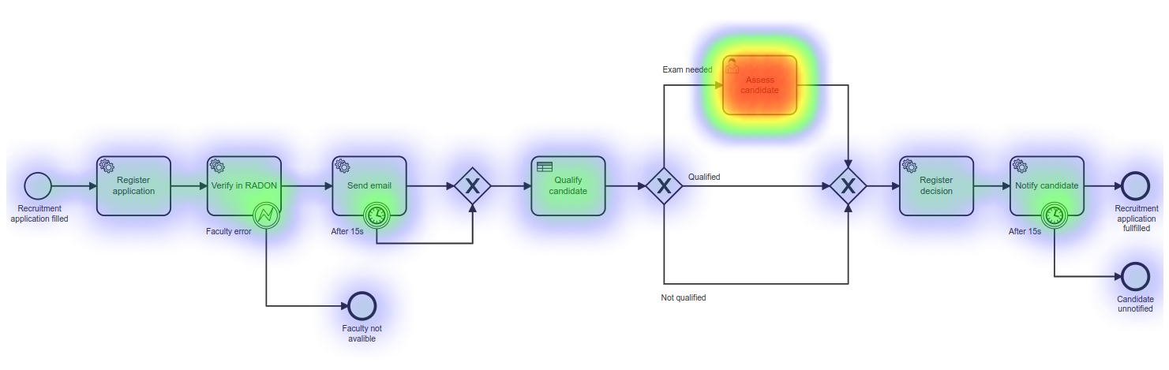Drawing 2: Process name 1 (“Caption Image” style)

TEXT.

